# California State University, Fresno

# DEPARTMENT OF COMPUTER SCIENCE

|  |  |  |  |  |  |
| --- | --- | --- | --- | --- | --- |
| Class: | **Algorithms & Data Structures** | | | Semester: | **Fall 2021** |
|  | | | | | |
| Points |  | Document author: | **Saishnu Ramesh Kumar** | | |
|  | Author’s email: | **saishnu_rk@mail.fresnostate.edu** | | |
| Laboratory number: | **Section 1, 11am to 12:50pm** | | |
|  | | | | | |

**1. Statement of Objectives**

For this assignment, we have been assigned to deal with Dynamic Programming which is a brand-new concept to me in Computer Science. The assignment deals with the matrix multiplication order and this assignment will display the optimal cost and the optimal parenthesis of the inputted matrix by the user. Dynamic Programming is used to solve various different sub problems and the problems that are also contained within the original sub problem. The time complexity of this would be O(n^3).

**2. Experimental Procedure**

For this program, two functions were created, matrixChainOrder and printOptParens. The matrixChainOrder function deals with the calculations of the matrices as well as calculating the optimal cost. It also helps with creating the parenthesization section as it also calls the printOptParens function. The printOptParens function mainly deals with putting the characters into the optimal parenthesis for example: ((AB)C). The main function includes the section where the user would input the number of matrices and would input the respective number of numbers into the program. It also calls the matrixChainOrder function to print the output for both optimal parts.

**3. Analysis**

Screenshot of Terminal Output:

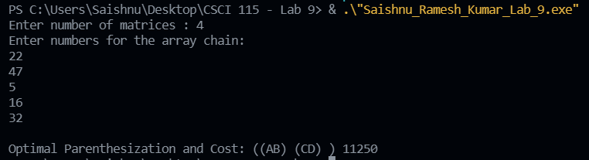

**4. Encountered Problems**

Since dynamic programming is fairly new to me, I came across getting stuck here and there on what to do but I also came across compiler errors throughout the duration of my coding time. Fortunately, I was able to resolve all of them and was able to create the program.

**5. Conclusions**

To conclude, I believe that I would still need more practice when it comes to Dynamic Programming as this concept in Computer Science is still really new to me. The matrix order of multiplication application for Dynamic Programming is interesting to see as the program is intended to find the most optimal solutions for both the cost as well as the parenthesization.

**6. References**

Slides provided by TA during the lab session

<https://www.geeksforgeeks.org/matrix-chain-multiplication-dp-8/>

<https://www.thecrazyprogrammer.com/2017/05/matrix-chain-multiplication.html>

<https://www.techiedelight.com/initialize-matrix-cpp/>

<https://afteracademy.com/blog/matrix-chain-multiplication>